Data analysis &  continuous improvement process |  |  |  |  |  |  |  |  |  | 
Document no |  |  | RS-MP-05 |  |  |  |  | Written by |  |  |  | Mark.Kim
Rev no |  |  | 001
Rev. date | 2022.10.05 |  |  |  |  |  |  | Department |  |  |  | QM
Revised contents |  |  |  |  |  | Drift |  |  | Review |  |  |  | Approval
 |  |  |  |  |  | / |  |  | / |  |  |  | /
Revised Items | AS IS |  |  |  |  | TO BE
Agreement | QM | R&D
 | Opinion:

[Revision history]
Revision history summary |  |  | RS-MP-05
 |  |  | Revision | 001
 |  |  | Confidential | G1
Rev. no | Rev. date | Simple description of changed contents | Author | Post
001 | 2022.10.05 | Newly established. | Mark.Kim | QM

1. Purpose and scope
The purpose of this procedure is to determine, collect, and analyze the date generated from all processes in our company using various quality techniques to identify progress against the target for quality & management performance and to continuously improve it.

2. Apply scope
Applied to all processes

3. Definition of terms
3.1 Key performance indicator (KPI)
A key performance indicator is a quantitative indicator of the progress of a team or organization against important business objectives.
3.2 Customer satisfaction
A state in which customer demands are being met for tangible and intangible products purchased by customers.

4. Responsibility and authority
5.1 CEO
1) CEO is responsible for maintaining quality management system through continuous improvement
2) The CEO has the responsibility and authority to continuously maintain and support the
improvement results.
5.2 CQO
1) The CQO has the responsibility and authority to carry out tasks by being delegated the responsibility and authority of the CEO.
2) The CQO should report improvement implementation results to the CEO and follow-up management of several indicators.
5.3 The relevant department
1) The head of all department should manage & monitor key performance indicators continuously,
and, they should maintain monitoring & improved results.

5. Process mapping

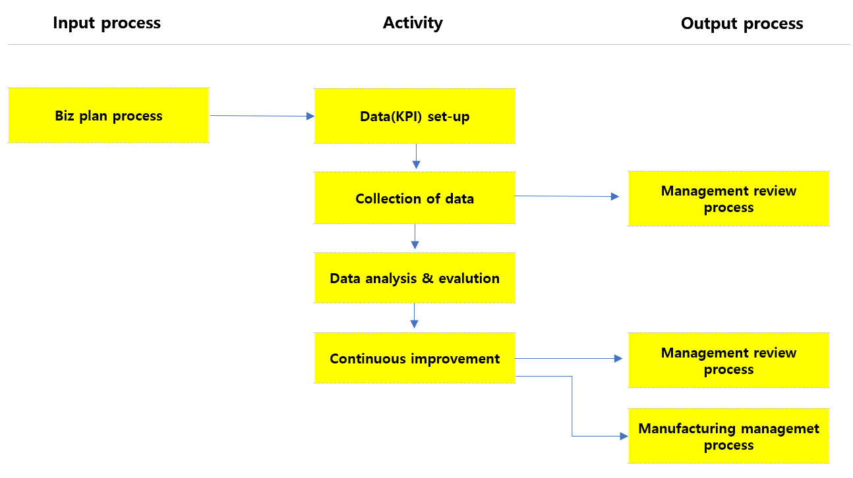

In  process | Input | Activity | Output | Out  process | Freq. | Review | Approval
Biz plan process | -. biz plan each team | -. Each teams prepare management sheet to control performance indicator based on KPI of each process. | -. KPI management sheet | - | 1x/year | Charged person | Each team leaders
-. | -. KPI management  sheet | -. The charged person of each teams collects relevant data and, key-in them in the KPI management sheet.  -. Once the KPI performance is not meet the defined goal, they should analyze what’s the cause its. And then recode them on the KPI management sheet. | -. KPI management sheet | -. Management review process | 1x/month | Charged person | Each team leaders
- | -. KPI management sheet | -. The leader each team submit KPI performance sheet to the QM team.  -. In charge of person of the QM summarize KPI performance sheets received from each team.  -. QM Leader review the summarized material. and make include agenda of business review board. | -. Summarized KPI | - | 1x/month | QM Leader | CQO
 | -. Summarized KPI | -. The leader each team reports KPI performance & analysis results to the CEO at biz review board meeting.  -. The CEO reviews the reported KPI performance. And, if there are additional improvements from a quality management point of view, instructs the relevant department for improvement.  -. CEO’s instructions for KPI should be review at next biz review board meeting. | -. Biz review board  minute | -. Management review process | 1x/month | CQO | CEO

7. Document record & preservation
Material | Form code | Dept | Life
KPI status summary | RS-MP-05-F001 | QM | 5years
KPI Analysis | RS-MP-05-F002 | QM | 5years

Appendix
KPI status summary RS-MP-05-F001
KPI Status summary  ( year) / ( Team) |  |  |  |  |  |  |  |  |  | 
Process | KPI | Freq. | Target | Meet  rate | Monthly performance
 |  |  |  |  | 1 | 2 | 3 | 4 | 5 |  | 6 | 7 | 8 | 9 | 10 | 11 | 12

KPI Analysis RS-MP-05-F002
KPI Analysis ( Year) |  |  |  |  |  | 
Process | KPI | Freq. | Target | OK/NG | The analysis for KPI performance

